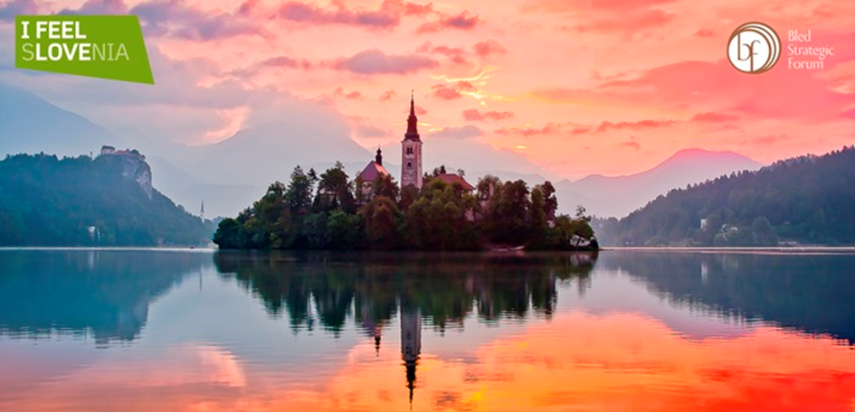

BLED STRATEGIC FORUM: “NEW REALITIES”
(4th – 5th September 2017, Bled)

TOURISM PANEL:
”Collaborative Economy:
Sharing, Cooperation or simply Business?”
(5th September 2017, Bled)
Grand Hotel Toplice, Grand Hall
Draft program:

Program, 4th September 2017 (Monday)

Bled Festival Hall:

13.00 – 14.00 Gathering and Reception
13.45 all participants are asked to be in the Hall, because of the direct broadcasting by the National Television
14.00 – 15.00 Opening of the 2017 BSF*
15.00 – 17.00 Leaders’ panel*

Grand Hotel Toplice, Grand Hall
20.00 – 22.00 Networking Reception with Ana Roš (the World’s Best Female Chef 2017)

Program, 5th September 2017 (Tuesday)

Tourism Panel, Grand Hotel Toplice , Grand Hall:

Collaborative economy: sharing, cooperation or simply business?*
10.00 OPENING
Zdravko Počivalšek, Minister of Economic Development and Technology of the Republic of Slovenia

10.10 – 10.25 Christ Costas, Editor at Large, National Geographic Traveler and
National Geographic World Legacy Awards Chairman

Keynote speaker
10.25 – 11.00 Manolis Psarros, Toposophy, CEO
COLLABORATIVE ECONOMY IN TOURISM

11.00 – 12.25 ROUND TABLE: (Moderator: Igor E. Bergant)

Collaborative Economy: Sharing, Cooperation or simply Business
Panelists:
- Christian de Barrin, HOTREC, CEO
- Carlos Villaro Lassen, EHHA, Secretary General
- Daniela Wagner, PATA
- Eva Štravs Podlogar, MEDT, State secretary,
- Dr. Janja Hojnik, University of Maribor, FACULTY OF LAW,
- Klemens Himpele, MA 23 – Economy, Labour, and Statistics, Vienna City

12.30 TASTE SLOVENIA - Culinary experience with top Slovenian chefs
(Terrace, Grand Hotel Toplice )

* The official language of the Bled Strategic Forum is English.

Please, find additional information at the official web-site of the Bled Strategic Forum:
http://www.bledstrategicforum.org/

